- 1. Cat6 Ethernet Cable — T568B Wiring Diagram

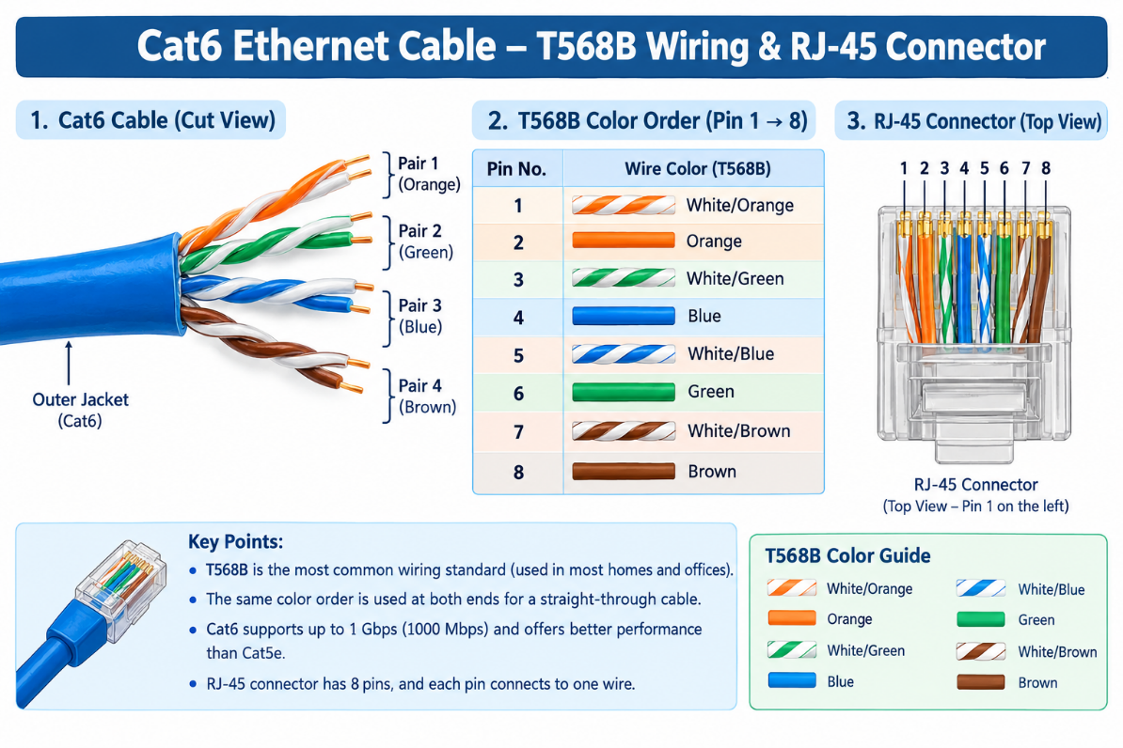

- Three Types of Network Cables

Cable Type | Real-World Use | Why?
Cat5e | Wi-Fi router to computer | Supports speeds up to 1 Gbps and is affordable.
Cat6 | Zomato POS terminal | Provides a fast, reliable wired connection.
Fiber  optic | IPL streaming server | Supports high bandwidth and long-distance data transmission.
- RJ-45 Crimping Process.

Watch this YouTube tutorial: How to Correctly Crimp RJ45 Network Cables — T568A and T568B.

YouTube
Steps:
- Cut the Ethernet cable to the required length.
- Strip about 2–3 cm of the outer jacket without damaging the inner wires.
- Straighten the eight wires and arrange them in T568B color order.
- Trim the wire ends evenly.
- Insert all eight wires fully into the RJ-45 connector.
- Use an RJ-45 crimping tool to secure the connector.
- Repeat at the other end using the same wiring standard.
- Test the cable with a cable tester.

- Gaming Zone for IPL Screening

Recommended cable: Cat6 Ethernet cable.
Connector: RJ-45 connector for Ethernet devices.
Reason: Cat6 provides high-speed, reliable wired connections between the router or switch, gaming consoles, and compatible network devices. Use HDMI cables to connect consoles to TVs or projectors for video and audio.

5. Network Cable Photo and Description
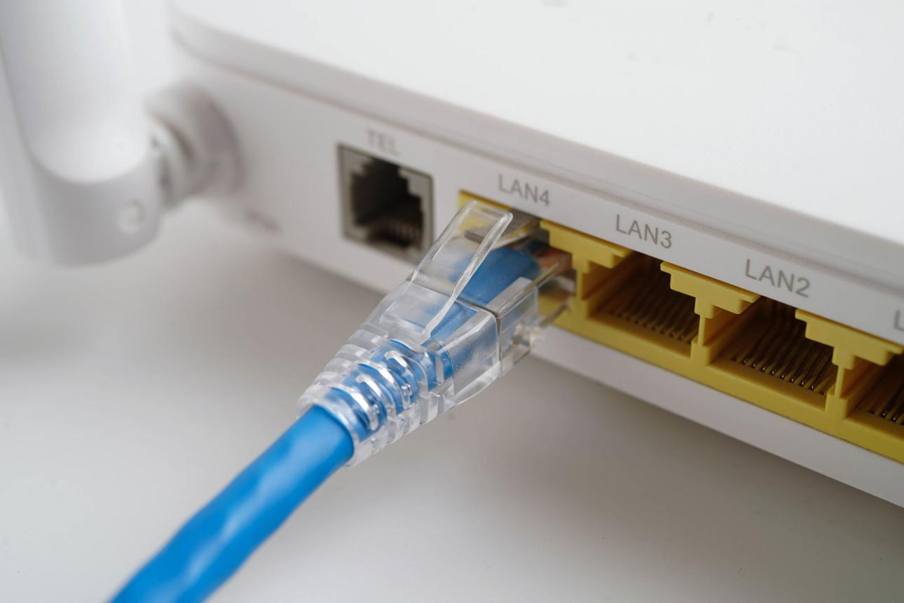
- Cable type: Ethernet cable, typically Cat5e or Cat6.
- Connector: RJ-45.
- Devices connected: Wi-Fi router and computer, TV, or gaming console.
- Purpose: Provides a stable wired network connection and can reduce interference compared with Wi-Fi.

